**Luminous Onion Design Guide**

|  |  |
| --- | --- |
| **Project Location:** | <https://gitlab.com/wgu-gitlab-environment/student-repos/zkarpi1/d424-software-engineering-capstone/-/tree/v1> |

# Back-end Design

Luminous Onion is built with Java 17 and is required to build and during runtime. Maven is the choice build tool while downloads and sets up all the requirements. H2 database is used as our database of choice.

## Technologies:

* Java 17
* Springboot Framework
* H2 Database

## Class Diagram

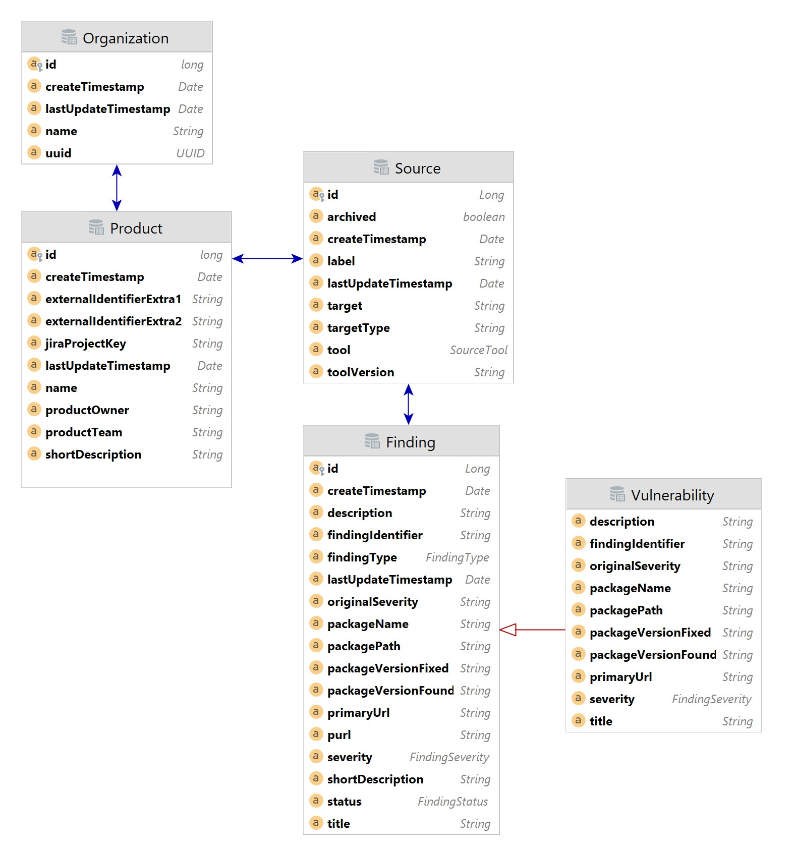

# Front-end Design

For the front-end Luminous Onion uses Node and React to create an interactive interface that talks directly with our spring-boot backend. Below are design documents including a sitemap and two mid-fidelity wireframe mockups of the UI.

## Technologies:

* Node JS
* React Framework
* MUI Framework
* Slickgrid

## Site Map

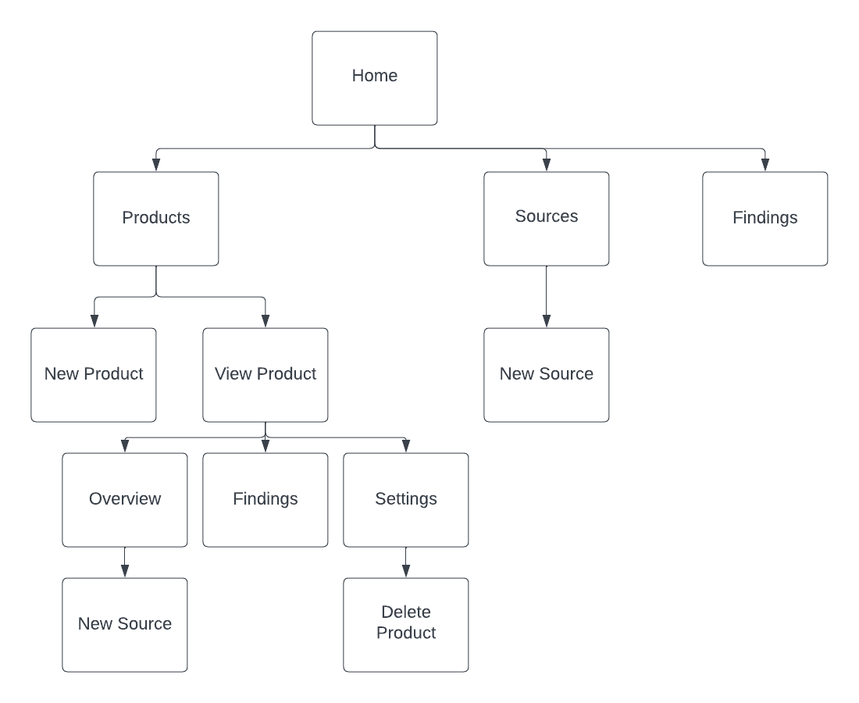

## Design Examples

### Home Screen

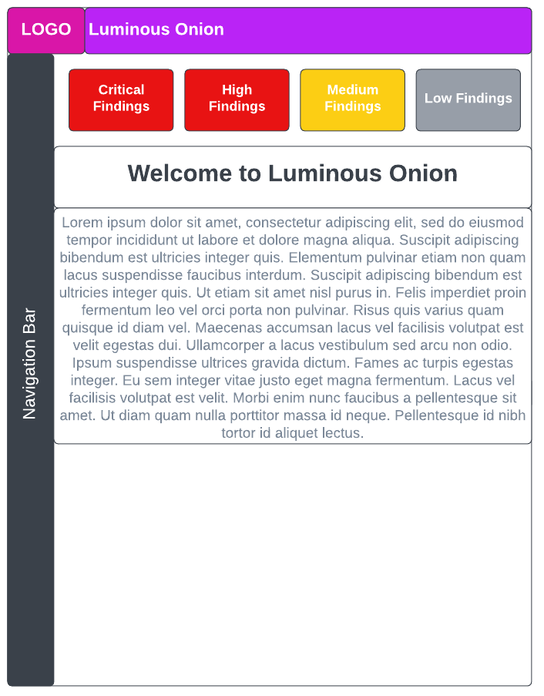

### Product View

